**Units**:

Capacitance:

Voltage:

Inductance:

Resistance:

[p=e-12, n=e-9, =e-6, m=e-3, K=e+3, M=e+6, G=e+9]

**R-C Circuits**:

Average:

Note that, in a series RC circuit

Where D is the decimal of time the voltage source is at Vs, and (1-D) is the complement when the voltage source is off.

Ripple voltage:

**LRC Circuits**:

Low pass filters:

* Vin + L + (R||C || Vout)
* Vin + L + (R || Vout)
* Vin + R + (C || Vout)
* Vin + L + (C || Vout)
* Vin + R + L + (C || Vout) (has resonance)

High pass filters:

* Vin + R + (L || Vout)
* Vin + C + (R || Vout)
* Vin + C + (L || Vout)
* Vin + R + C + (L || Vout)

Band pass / notch filter:

* Vin + R + (L || C || Vout) – filter to a specific band
* Vin + L + C + (R || Vout) – filter everything except a specific band

**Energy**:

**Second-order circuits**:

In a parallel RLC, . In series, . In other circuits:

* Solve for the transfer function
* Replace jw with s
* Set coefficient for highest order s-term in the denominator to 1. Then, the denominator is equivalent to the characteristic equation: . Note that this is a solution to:
* Solve for

Note that, given a transfer function of the form WHERE K IS REAL:

Then the angle is:

And the magnitude is:

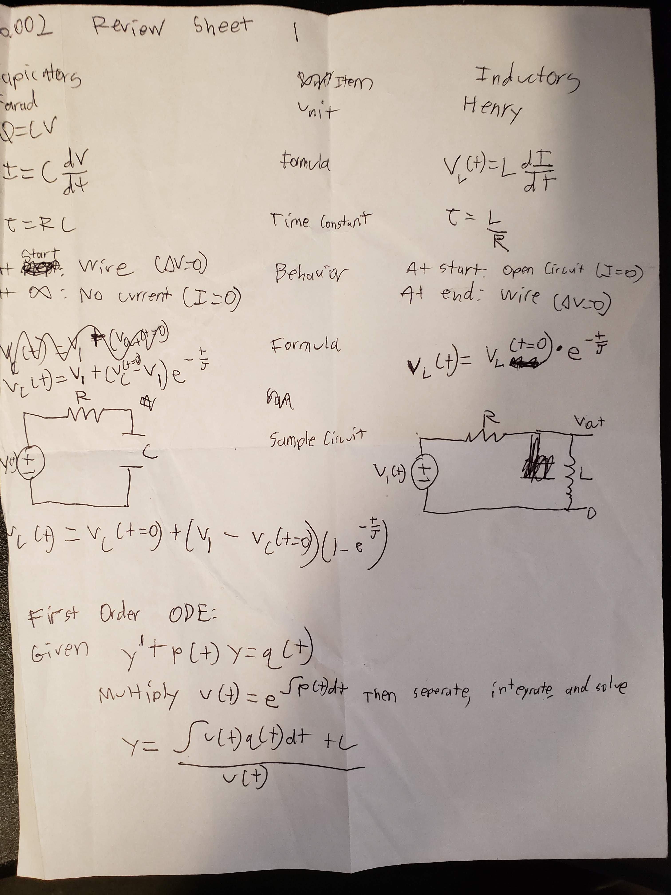



Mobility analog:

Power = I*V Power = ???? (<https://iesc-s2.mit.edu/6002/_static/F18/lecturenotes/Lecture16.pdf>)

U is terminal velocity, p is power, m is mass, k is the spring constant, x is displacement, f is force,

Mass = capicator. (

Inductor = spring ( ⬄ )

Resister = damper ()

Units: